**Project plan**

Our Project Name is Find Doctor. Any user can access in our website. Any patient can easily take appointment in choses her/his diseases.

**Group Member**

**Group name ID Number**

Faruq Hossain 191-15-2700

Farzana Akter 191-15-2579

Abu Sufian 191-15-2532

Abdur Rahaman 191-15-

**Version history**

|  |  |  |  |
| --- | --- | --- | --- |
| Version | Date | Author | Description |
| 0.1 | 13.4.2022 | Faruq Hossain | ALL |
| 0.2 | 13.4.2022 | Farzana Akter | ALL |
| 0.3 | 13.4.2022 | Abu Sufian | ALL |
| 0.3 | 13.4.2022 | Abdur Rahaman | ALL |
|  |  |  |  |
|  |  |  |  |
|  |  |  |  |
|  |  |  |  |
|  |  |  |  |
|  |  |  |  |

**Contents**

1 Introduction 4

1.1 **Purpose and scope of project** 4

1.2 Product and environment 4

1.3 Customer's current system and other similar systems 4

1.4 Project constraints 4

1.5 Definitions, abbreviations and acronyms 4

2 Project organisation 5

2.1 Group members 5

**2.2 Customer** 5

2.3 Related organisations 5

3 Requirements 9

**6.1 Functional requirements (main goals) 9**

6.2 Non-functional requirements goals 9

6.2.1 Usability goals 9

6.2.2 Performance goals 9

6.2.3 Reliability goals 9

6.2.4 Security goals 9

6.3 User interface requirements (main goals) 9

**5 System Design 9**

**7.1 Use Case Diagram 10**

**7.2 E-R Diagram 10**

**7.2 Prototype (Tools: Justinmind or Invision Tools based on FR) 10**

6 Risk management 9

**7.1 Risk list** 10

7.2 Risk monitoring 10

6 References 11

7 Open issues 11

8 **Ideas for further development** 11

APPENDIX A […Z] 11

# Introduction

## Purpose and scope of project

## INTRODUCTION

Doctors have a noble profession. Doctors are work for patients’ safety and work. Now a days digital platform is important for man and women. Bangladesh is a developing country. Our network system is improved day by day. Our project is mainly online base website. Our project name is “Find Doctor”. Here we use PHP language to develop our project. Our project main purpose easy way how to find doctor and take appointment in our doctors. Any patient can easily access our website and take appointment with our doctors and also take treatment easily. A patients can easily talk to our doctors and discuss her/his problem. Here we use many types of features for doctors and patients like they can easily login and logout this website, patient create an appointment and find doctor, doctor can search patient and add description. its a easy to find doctor and patient can easily take treatment here this website.

### Existing System

The present system is online base system. Patient and doctors easily take advantage in this website. A manual system has following disadvantages .

* It’s a limited system and fewer users friendly.
* Searching of particular information is critical it takes lot of time.
* In the existing system patent only have to rely on their own judgment.
* In the manual system patient need bare the lot of time and cost.
* The existing system Patient cannot get a complete idea of ​​the place of their choice.
* Conduct of examination and compilation of result is a tedious process.
* The existing system Patient may not get any quick help if they have an accident.
* Limited sharing is possible if the data is in the form of paper or disk drives.
* The manual system gives us less security for saving data, some data may be lost due to mismanagement.

### Proposed System

As the Since the purpose of find doctors website base system and to take easy treatment in patient in our appointed doctors. The system after careful analysis has been identified to be presented with the following modules:

**User Signup/login:** User can signup/login a user for a program. Easy appointment system in our doctor and easy to find any doctor. Doctor can find which patient are access or want take appointment. Easy to search doctors.

Admin can easily add doctors and delete doctors.

* **Patient Appoint the Doctor:** From patient to his selected Doctor.Patient see Doctor details then book Doctor chooses Destination.
* **Doctor Panel:** Doctor can access all the Appointment and Search Patient which person book appointment then add description for the patient.
* **Chatting System:** The user can discuss his or her plans with his or her friends. The user can also speak with the administrator.
* **Admin panel:** Admin can access all of think.

## Advantages for Patient

Advantages for the patient are explained below

* **Time and Cost Saving:** Patient will be able to find out where he is going very quickly. And you don't have to go out for home, it will save your cost.
* **Communication and find more information**: They chat admin in this website.
* **Blood Donner:** If any patient have donate her/his blood, they can find almost all of the services they need on the website.
* **Find doctor at Doorstep:** Our system is a platform to provide find doctor at doorstep.

## Customer's current system and other similar systems

Having patient and doctor information easily accessible can help patient and doctor support representatives provide better and faster customer service.

Access to patient and doctor data can help easily identify all thigs

## Definitions, abbreviations and acronyms

Basic user Doctor Patient

End-user Last year student

PB Product Backlog

SB Sprint Backlog

super-user admin user

UI User interface.

# Project organisation

## Group members

Faruq Hossain- Developer

Farzana Akter-

Abu Sufian-

Abdur Rahaman-

## Customer

Doctor

Patient

## Related organisations

None

# Requirements

## Functional requirements (main goals)

"Functional requirement describe what a system should do." [4] Functional requirements of our system are explained below.

**Admin:**

* Admin can manage all system
* Admin must have login admin panel
* Admin can update doctor, patient, Manage appointment, view feedbace.

**General User:**

* Patient And Doctor must have valid User id and Password to login thus creating their individual profiles.
* Doctor can see any patient which patient booked her/his appointment.
* Patient can see all the doctor and appointment the Doctor.
* Any patient find any blood doner patient.

**IT Officer:**

* Report on the applications security. Possibly improve.
* Report on the error handling, and logs. Possibly improve.
* Implement HAKA login. (Least priority)

## Non-functional requirements goals

### Usability goals

Requirement that specifies criteria that can be used to judge the operation of a system are called non functional requirements. [5] Non functional requirements of our system are mentioned below

* Secure access of confidential data (user’s details).
* Maximum time availability
* Better component design to get efficiency at peak time.
* Flexible service based architecture will be highly desirable for future extension.
* User signup facility is accessible by admin only.

### Performance goals

Some mechanism may use some refactor which might lead to a shorter time of execution and increase performance.

### Reliability goals

None, at the moment.

### Security goals

As the main functionality has a goal related to this, performing that security analysis of the application there might bring up something.

## User interface requirements (main goals)

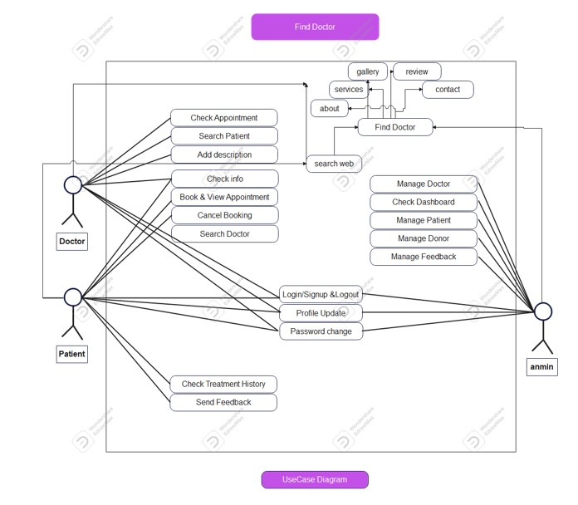

# Risk management

Risk management is the process of identifying, monitoring, assessing and neutralizing threats and roadblocks to a project. Risks could stem from a wide variety of situations such as technical complexities, dropouts, management errors etc. Severe scenarios may cause the project to fail partially or completely.

Implementing a risk management plan could significantly help reduce the chances of a project failure. Carefully monitoring and estimation of potential risks shall certainly help making the project a success.

## Risk list

List the identified risks or summary at the start of the project.

A separate and updated risk list is maintained at MMT.

**Table 7.1. Project risks.**

|  |  |
| --- | --- |
| Risk ID | Explanation , severity/impact , probability , size/importance |
| Dropouts | Chances are that members might dropout from the project due to motivation or complexity of code/concept.  We are dropout Home-delivery medicine services for some critical reason.  Impact: Low  Probability: Low  Importance: This might lead to increase in other members tasks and as a result this could happen for them. |
| Estimation and scheduling | Some tasks may be underestimated/overestimated and the scheduled wrong.  This may increase time to reach the goals.  For taking services from doctor or For convincing doctor to work with us take some time.  Impact: Medium  Probability: Medium  Importance: To ensure project deadline is utilised well, this needs to be done carefully. |
| Productivity issues | Productivity might be low for some because of unfamiliarity of the technology used.  We are using live chatting system via website and keep monitoring issues. Impact: Low  Probability: Low |
| Gold plating | Premature optimisation or doing unnecessary implementation costs the project time. We are trying to add some Home delivery medicine service and it take some time. Impact: Medium  Probability: Medium  Importance: This may happen passively, without the developer noticing. Proper code reviews should be done in order to avoid it. |
| Technical risk | Some difficulties might come up setting up or adding new tools/technology to the existing solution to achieve a task. That may prove challenging. Like Online live chatting system with doctor and patient. Adding live chat to the website is not a easy process.  Impact: Medium  Probability: Low  Importance: Careful planning should help prevent this. |
| Inadequate resource | The project size might be quite big for the available resources considering not everyone has deep understandings of the technologies used.  To add so many doctor for servicing and their treatment via live chat. Some doctor and most of the patient not familiar with this kind of technology or site. Impact: Medium  Probability: High  Importance: This may cause a delay on getting started with the tasks. |
|  |  |

## Risk monitoring

Monitoring risks and keeping them in checks are essential to avoid any unexpected circumstances that may jeopardize the project.

Risk management is done at MMT tool.

Steps we would take to monitor risks are:

* Weekly meetings
* Task progress
* Re-assign task to another person if necessary

# References

[1] W3Schools. PHP, HTML, CSS, BOOTSTRAP, JAVASCRIPT Tutorial. Available at: <https://www.w3schools.com/nodejs/>. Last read 13/4/2022.

[2] <https://tailwindcss.com/docs/preflight#headings-are-unstyled> Last read 13/4/2022.

# Open issues

……..

# Ideas for further development

1. Adding the possibility to install the application or add it to desktop

2. Improving the offline user experience (at the moment, when offline, the standard dinosaur game of Chrome begins)

3. Suggesting a UI revamp

# APPENDIX A […Z]

The original task list provided by the client

